**Datos insertados en base de datos Inversoft**

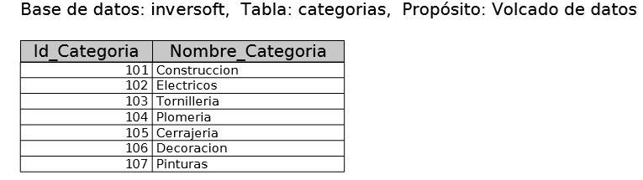

INSERT INTO `categorias` (`Id_Categoria`, `Nombre_Categoria`) VALUES

(101, 'Construccion'),

(102, 'Electricos'),

(103, 'Tornilleria'),

(104, 'Plomeria'),

(105, 'Cerrajeria'),

(106, 'Decoracion'),

(107, 'Pinturas');

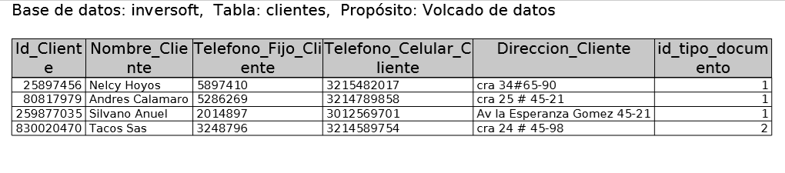

INSERT INTO `clientes` (`Id_Cliente`, `Nombre_Cliente`, `Telefono_Fijo_Cliente`, `Telefono_Celular_Cliente`, `Direccion_Cliente`, `id_tipo_documento`) VALUES

(25897456, 'Nelcy Hoyos', '5897410', '3215482017', 'cra 34#65-90', 1),

(80817979, 'Andres Calamaro', '5286269', '3214789858', 'cra 25 # 45-21', 1),

(259877035, 'Silvano Anuel', '2014897', '3012569701', 'Av la Esperanza Gomez 45-21', 1),

(830020470, 'Tacos Sas', '3248796', '3214589754', 'cra 24 # 45-98', 2);

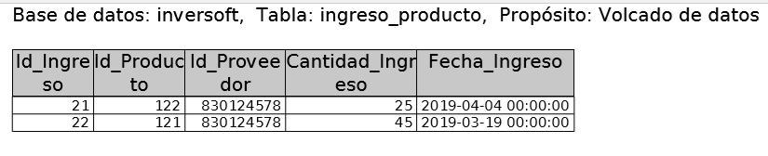

INSERT INTO `ingreso_producto` (`Id_Ingreso`, `Id_Producto`, `Id_Proveedor`, `Cantidad_Ingreso`, `Fecha_Ingreso`) VALUES

(21, 122, 830124578, 25, '2019-04-04 00:00:00'),

(22, 121, 830124578, 45, '2019-03-19 00:00:00');

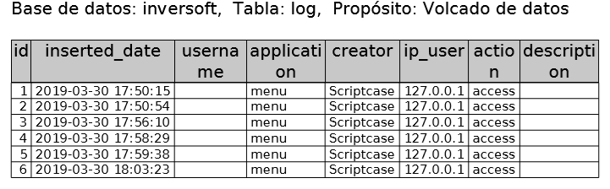

INSERT INTO `log` (`id`, `inserted_date`, `username`, `application`, `creator`, `ip_user`, `action`, `description`) VALUES

(1, '2019-03-30 17:50:15', '', 'menu', 'Scriptcase', '127.0.0.1', 'access', ''),

(2, '2019-03-30 17:50:54', '', 'menu', 'Scriptcase', '127.0.0.1', 'access', ''),

(3, '2019-03-30 17:56:10', '', 'menu', 'Scriptcase', '127.0.0.1', 'access', ''),

(4, '2019-03-30 17:58:29', '', 'menu', 'Scriptcase', '127.0.0.1', 'access', ''),

(5, '2019-03-30 17:59:38', '', 'menu', 'Scriptcase', '127.0.0.1', 'access', ''),

(6, '2019-03-30 18:03:23', '', 'menu', 'Scriptcase', '127.0.0.1', 'access', '');

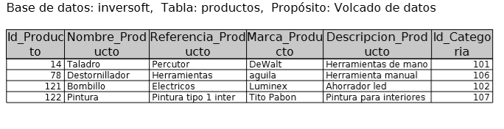

INSERT INTO `productos` (`Id_Producto`, `Nombre_Producto`, `Referencia_Producto`, `Marca_Producto`, `Descripcion_Producto`, `Id_Categoria`) VALUES

(14, 'Taladro', 'Percutor', 'DeWalt', 'Herramientas de mano', 101),

(78, 'Destornillador', 'Herramientas ', 'aguila', 'Herramienta manual', 106),

(121, 'Bombillo', 'Electricos', 'Luminex', 'Ahorrador led', 102),

(122, 'Pintura', 'Pintura tipo 1 inter', 'Tito Pabon', 'Pintura para interiores', 107);

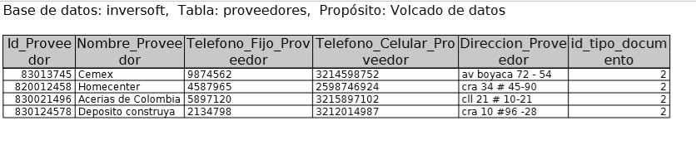

INSERT INTO `proveedores` (`Id_Proveedor`, `Nombre_Proveedor`, `Telefono_Fijo_Proveedor`, `Telefono_Celular_Proveedor`, `Direccion_Proveedor`, `id_tipo_documento`) VALUES

(83013745, 'Cemex', '9874562', '3214598752', 'av boyaca 72 - 54 ', 2),

(820012458, 'Homecenter', '4587965', '2598746924', 'cra 34 # 45-90', 2),

(830021496, 'Acerias de Colombia', '5897120', '3215897102', 'cll 21 # 10-21', 2),

(830124578, 'Deposito construya', '2134798', '3212014987', 'cra 10 #96 -28', 2);

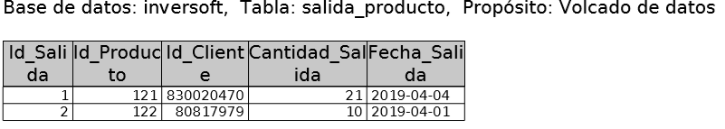

INSERT INTO `salida_producto` (`Id_Salida`, `Id_Producto`, `Id_Cliente`, `Cantidad_Salida`, `Fecha_Salida`) VALUES

(1, 121, 830020470, 21, '2019-04-04'),

(2, 122, 80817979, 10, '2019-04-01');

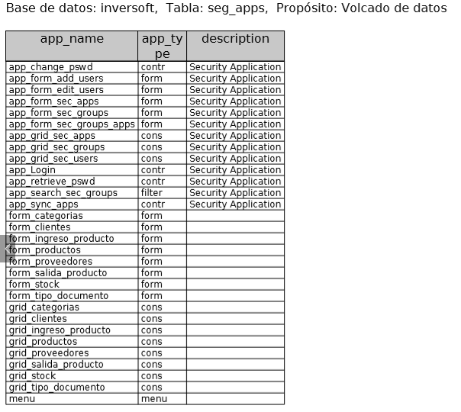

INSERT INTO `seg_apps` (`app_name`, `app_type`, `description`) VALUES

('app_change_pswd', 'contr', 'Security Application'),

('app_form_add_users', 'form', 'Security Application'),

('app_form_edit_users', 'form', 'Security Application'),

('app_form_sec_apps', 'form', 'Security Application'),

('app_form_sec_groups', 'form', 'Security Application'),

('app_form_sec_groups_apps', 'form', 'Security Application'),

('app_grid_sec_apps', 'cons', 'Security Application'),

('app_grid_sec_groups', 'cons', 'Security Application'),

('app_grid_sec_users', 'cons', 'Security Application'),

('app_Login', 'contr', 'Security Application'),

('app_retrieve_pswd', 'contr', 'Security Application'),

('app_search_sec_groups', 'filter', 'Security Application'),

('app_sync_apps', 'contr', 'Security Application'),

('form_categorias', 'form', ''),

('form_clientes', 'form', ''),

('form_ingreso_producto', 'form', ''),

('form_productos', 'form', ''),

('form_proveedores', 'form', ''),

('form_salida_producto', 'form', ''),

('form_stock', 'form', ''),

('form_tipo_documento', 'form', ''),

('grid_categorias', 'cons', ''),

('grid_clientes', 'cons', ''),

('grid_ingreso_producto', 'cons', ''),

('grid_productos', 'cons', ''),

('grid_proveedores', 'cons', ''),

('grid_salida_producto', 'cons', ''),

('grid_stock', 'cons', ''),

('grid_tipo_documento', 'cons', ''),

('menu', 'menu', '');

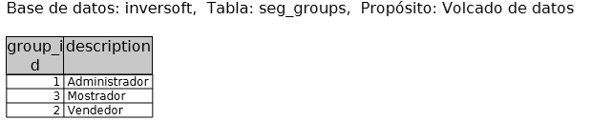

INSERT INTO `seg_groups` (`group_id`, `description`) VALUES

(1, 'Administrador'),

(3, 'Mostrador'),

(2, 'Vendedor');

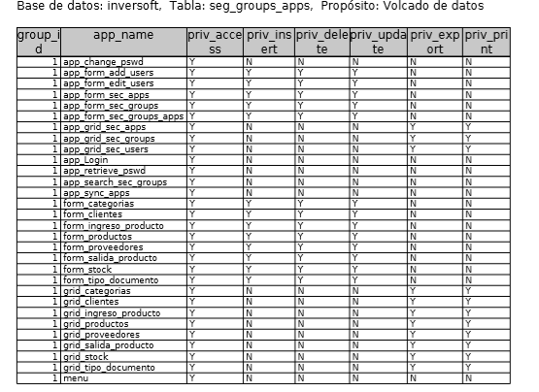

INSERT INTO `seg_groups_apps` (`group_id`, `app_name`, `priv_access`, `priv_insert`, `priv_delete`, `priv_update`, `priv_export`, `priv_print`) VALUES

(1, 'app_change_pswd', 'Y', 'N', 'N', 'N', 'N', 'N'),

(1, 'app_form_add_users', 'Y', 'Y', 'Y', 'Y', 'N', 'N'),

(1, 'app_form_edit_users', 'Y', 'Y', 'Y', 'Y', 'N', 'N'),

(1, 'app_form_sec_apps', 'Y', 'Y', 'Y', 'Y', 'N', 'N'),

(1, 'app_form_sec_groups', 'Y', 'Y', 'Y', 'Y', 'N', 'N'),

(1, 'app_form_sec_groups_apps', 'Y', 'Y', 'Y', 'Y', 'N', 'N'),

(1, 'app_grid_sec_apps', 'Y', 'N', 'N', 'N', 'Y', 'Y'),

(1, 'app_grid_sec_groups', 'Y', 'N', 'N', 'N', 'Y', 'Y'),

(1, 'app_grid_sec_users', 'Y', 'N', 'N', 'N', 'Y', 'Y'),

(1, 'app_Login', 'Y', 'N', 'N', 'N', 'N', 'N'),

(1, 'app_retrieve_pswd', 'Y', 'N', 'N', 'N', 'N', 'N'),

(1, 'app_search_sec_groups', 'Y', 'N', 'N', 'N', 'N', 'N'),

(1, 'app_sync_apps', 'Y', 'N', 'N', 'N', 'N', 'N'),

(1, 'form_categorias', 'Y', 'Y', 'Y', 'Y', 'N', 'N'),

(1, 'form_clientes', 'Y', 'Y', 'Y', 'Y', 'N', 'N'),

(1, 'form_ingreso_producto', 'Y', 'Y', 'Y', 'Y', 'N', 'N'),

(1, 'form_productos', 'Y', 'Y', 'Y', 'Y', 'N', 'N'),

(1, 'form_proveedores', 'Y', 'Y', 'Y', 'Y', 'N', 'N'),

(1, 'form_salida_producto', 'Y', 'Y', 'Y', 'Y', 'N', 'N'),

(1, 'form_stock', 'Y', 'Y', 'Y', 'Y', 'N', 'N'),

(1, 'form_tipo_documento', 'Y', 'Y', 'Y', 'Y', 'N', 'N'),

(1, 'grid_categorias', 'Y', 'N', 'N', 'N', 'Y', 'Y'),

(1, 'grid_clientes', 'Y', 'N', 'N', 'N', 'Y', 'Y'),

(1, 'grid_ingreso_producto', 'Y', 'N', 'N', 'N', 'Y', 'Y'),

(1, 'grid_productos', 'Y', 'N', 'N', 'N', 'Y', 'Y'),

(1, 'grid_proveedores', 'Y', 'N', 'N', 'N', 'Y', 'Y'),

(1, 'grid_salida_producto', 'Y', 'N', 'N', 'N', 'Y', 'Y'),

(1, 'grid_stock', 'Y', 'N', 'N', 'N', 'Y', 'Y'),

(1, 'grid_tipo_documento', 'Y', 'N', 'N', 'N', 'Y', 'Y'),

(1, 'menu', 'Y', 'N', 'N', 'N', 'N', 'N');

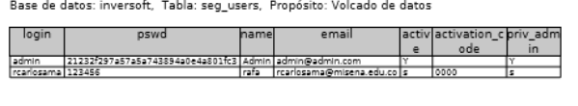

INSERT INTO `seg_users` (`login`, `pswd`, `name`, `email`, `active`, `activation_code`, `priv_admin`) VALUES

('admin', '21232f297a57a5a743894a0e4a801fc3', 'Admin', 'admin@admin.com', 'Y', NULL, 'Y'),

('rcarlosama', '123456', 'rafa', 'rcarlosama@misena.edu.co', 's', '0000', 's');

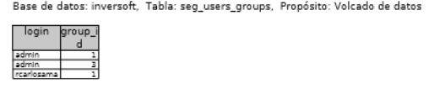

INSERT INTO `seg_users_groups` (`login`, `group_id`) VALUES

('admin', 1),

('admin', 3),

('rcarlosama', 1);

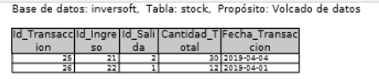

INSERT INTO `stock` (`Id_Transaccion`, `Id_Ingreso`, `Id_Salida`, `Cantidad_Total`, `Fecha_Transaccion`) VALUES

(25, 21, 2, 30, '2019-04-04'),

(26, 22, 1, 12, '2019-04-01');

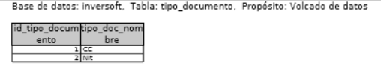

INSERT INTO `tipo_documento` (`id_tipo_documento`, `tipo_doc_nombre`) VALUES

(1, 'CC'),

(2, 'Nit');